LCEL is a changing concept in lang chain, helps to put all the logics into one component using | pipe symbol

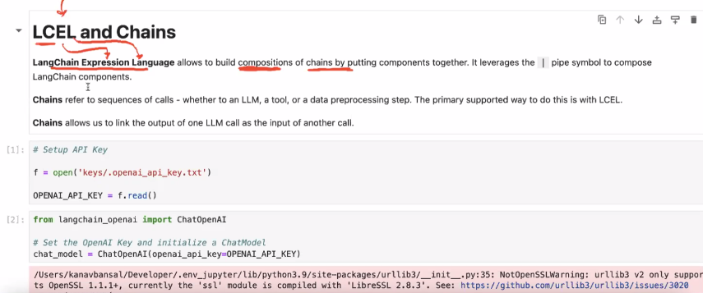

**Difference between stream and invoke**

1. Stream – Gives very large response
2. I